https://www.wpbeginner.com/beginners-guide/what-is-the-best-way-to-manage-passwords-for-wordpress-beginners/:

What is the Best Way to Manage Passwords for WordPress Beginners (wpbeginner.com)
Last updated on June 18th, 2014 by Editorial Staff
Have you ever felt overwhelmed by the number of different username and passwords you have to remember? Recently one of our users asked us for the best way to manage passwords for WordPress users? In this article, we will show you how to PROs manage their password by sharing 3 of the best password management tools that you should start using RIGHT AWAY.


Contents
Why You Need to Use a Password Manager? Error! Bookmark not defined.
1. LastPass 2
2. Password 3
3. Dashlane 4
Conclusion: 4

Why You Need to Use a Password Manager?
Most people have been using a couple of very easy to remember passwords for years without any problem. That’s NOT SAFE.
As proven by a number of recent hacks across major websites, if a malicious user gain access to all this information, then they can cause serious damage. This is not just a horror story that we tell users to scare them. It is true and happens every day to hundreds of people around the globe.
This is why security experts and other professionals recommend users to use STRONG and UNIQUE passwords.
Now you’re probably wondering how do you remember it all when there are so many different passwords such as email accounts, web hosting, social accounts, WordPress admin area, etc.
That’s why you need a password manager.
A password manager stores all your passwords and allow you to manage them using one master password. It also helps you generate strong password when you are creating new accounts and then store them on the cloud.
The best part about password managers is that they have an auto-fill functionality. This way you never have to remember or enter anything for sites that you already have an account on.
You can use your password manager app on all your devices, and it can easily import passwords stored in your browser.
Here is a list of the 3 best Password Management Apps in the market.

1. LastPass
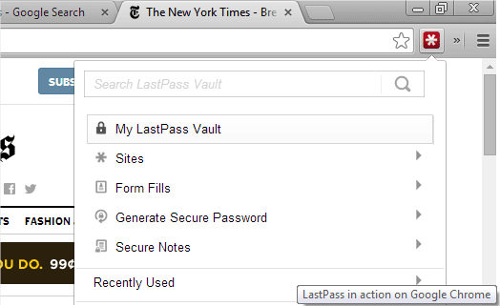
We use LastPass and feel very confident about recommending it to our users. First of all, it is available for free and the premium version is only $12 per year. That’s $1 for each month.
LastPass is available on Windows, Mac, Linux, iPad, iPhone, Android, Windows Phone, and Blackberry devices. This means no matter what device you use, LastPass will be there and you can easily sync all your passwords.
LastPass uses a master password to manage your password vault which makes this master password the key to all your online accounts.
LastPass allows you to use multi-factor authentication with Toopher, Duo Security, Transakt, Yubi Key, and of course Google Authenticator. This means that a person must know your password and have access to a randomly generated security code to enter your password vault.
If for some reason you need to share a password with someone like your assistant or developer, then LastPass allows you to do that securely. The other party will need to install LastPass on their browser to use shared passwords.
The password sharing functionality is great because your assistant never sees your password, so they can’t change the password. They can simply login and perform the tasks that you need them to do.

2. Password
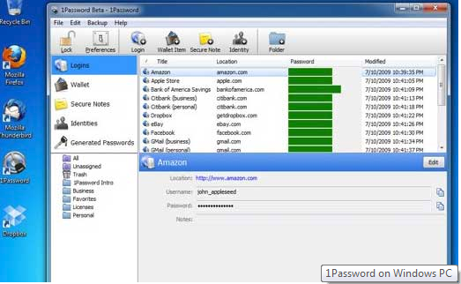
1Password is another popular password manager. It is cross-platform and available for mobile devices as well. There is no free version of 1Password however it is available for 30 day free trial.
It is also the most expensive password manager app in our list. You will have to buy a license for each device you install it on.
Most Apple users love it because of it’s intuitive user interface which makes it easier for new users to familiarize themselves with the app quickly.
One feature that is missing from 1Password is multi-factor or biometric authentication. It is one of the most frequently asked feature, and there is a good chance that it will be available in some future version.
Just like any good password management app, 1Password makes it super easy to generate and fill out password fields whenever you are creating a new account. It also autofills forms for you.
Sharing passwords with friends, family, and co-workers is not as intuitive as LastPass. Why? Because 1Password does not have their own cloud. You need to store your shared vault in a shared Dropbox folder for others to be able to access it. Also other users must have 1Password installed on their devices.

3. Dashlane
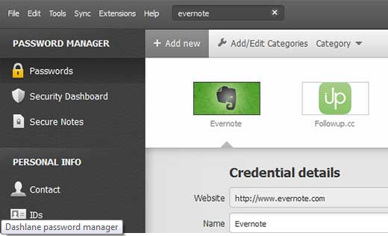
Dashlane is the third contender in our list of the best password management apps. Just like the other apps in the list, Dashlane is also available for all platforms, desktop and mobile.
It is completely free, with some features available only for premium users. The premium plan is available for $29.99 and includes unlimited backups and unlimited devices.
Dashlane allows you to generate strong passwords as you fill out online forms. It encrypts and stores your passwords and autofills passwords for you.
Dashlane also allows you to share passwords with friends and coworkers.
The free version of Dashlane does not allow you to sync passwords on all your devices, access passwords on the web, or save backups.

Conclusion:
LastPass is the most easy, secure and cost efficient solution for password management. Particularly if you run an online business, then you will appreciate the robust security features of LastPass. You can lock it down for countries, set two step authentication, and turn off cloud sync. You can run it for free for unlimited time on all your devices and it works great on all of them.
We are using LastPass for our password management.
We hope this article helped you learn how to manage passwords more efficiently and securely. As a website owner passwords are the most important security defense you got against hackers, so there should be no compromise on using unique and strong passwords for every account.
If you run a multi-user WordPress site then you can enforce strong passwords on your site and even reset passwords for all your users. You can also limit the number of login attempts a user can make.
If you liked this article, then subscribe to our YouTube Channel for more WordPress video tutorials. You can also find us on Twitter and Google+.
Popular on WPBeginner Right Now!
 | How to Fix the Error Establishing a Database Connection in WordPress |  | How to Properly Move Your Blog from WordPress.com to WordPress.org
 | Revealed: Why Building an Email List is so Important Today (6 Reasons) |  | Checklist: 15 Things You MUST DO Before Changing WordPress Themes

 | About the Editorial Staff  Editorial Staff at WPBeginner is a team of WordPress experts led by Syed Balkhi. Trusted by over 1.3 million readers worldwide.



